**Assignment 9.2:**

**Problem1:**

Create an HBase table named ‘clicks’ with a column family ‘hits’

Starting hbase shell:

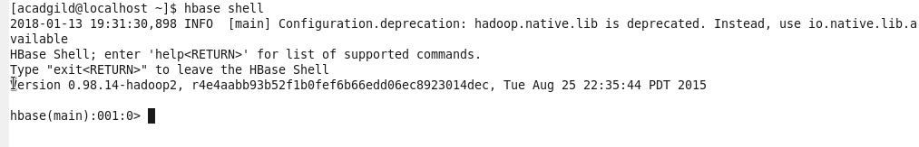

Creating HBase table named ‘clicks’ with a column family ‘hits’:

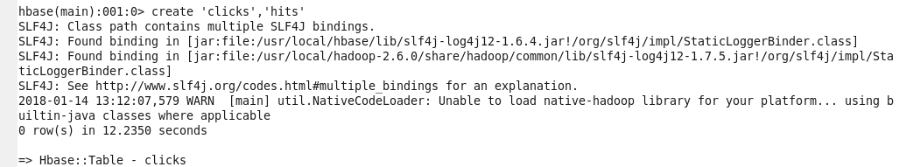

**Problem2:**

Add few records in the table and update some of them. Use IP Address as row-key. Scan the table to view if all the previous versions are getting displayed.

***Syntax: put ‘<table-name>’,’row-key’,’columnfamily:columnname’,’value’***

**Inserting data in to HBase using ‘IPAddress’ as row-key:**

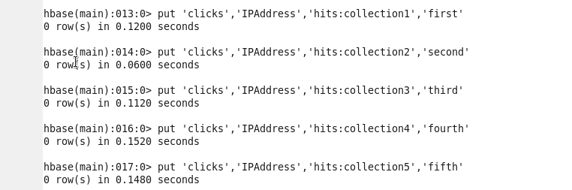

**Updating records in HBase table:**

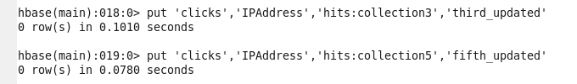

**Scanning HBase table:**

